2021 Colorado Association of Naturopathic Doctors Conference
Saturday, November 13, 2021

Embassy Suites by Hilton Denver Tech Center North, Denver, Colorado
CMEs: 7.0 Total – 2.0 Pharmacy & 5.0 General

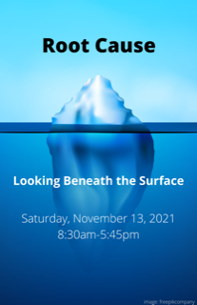
Meet Our Speakers

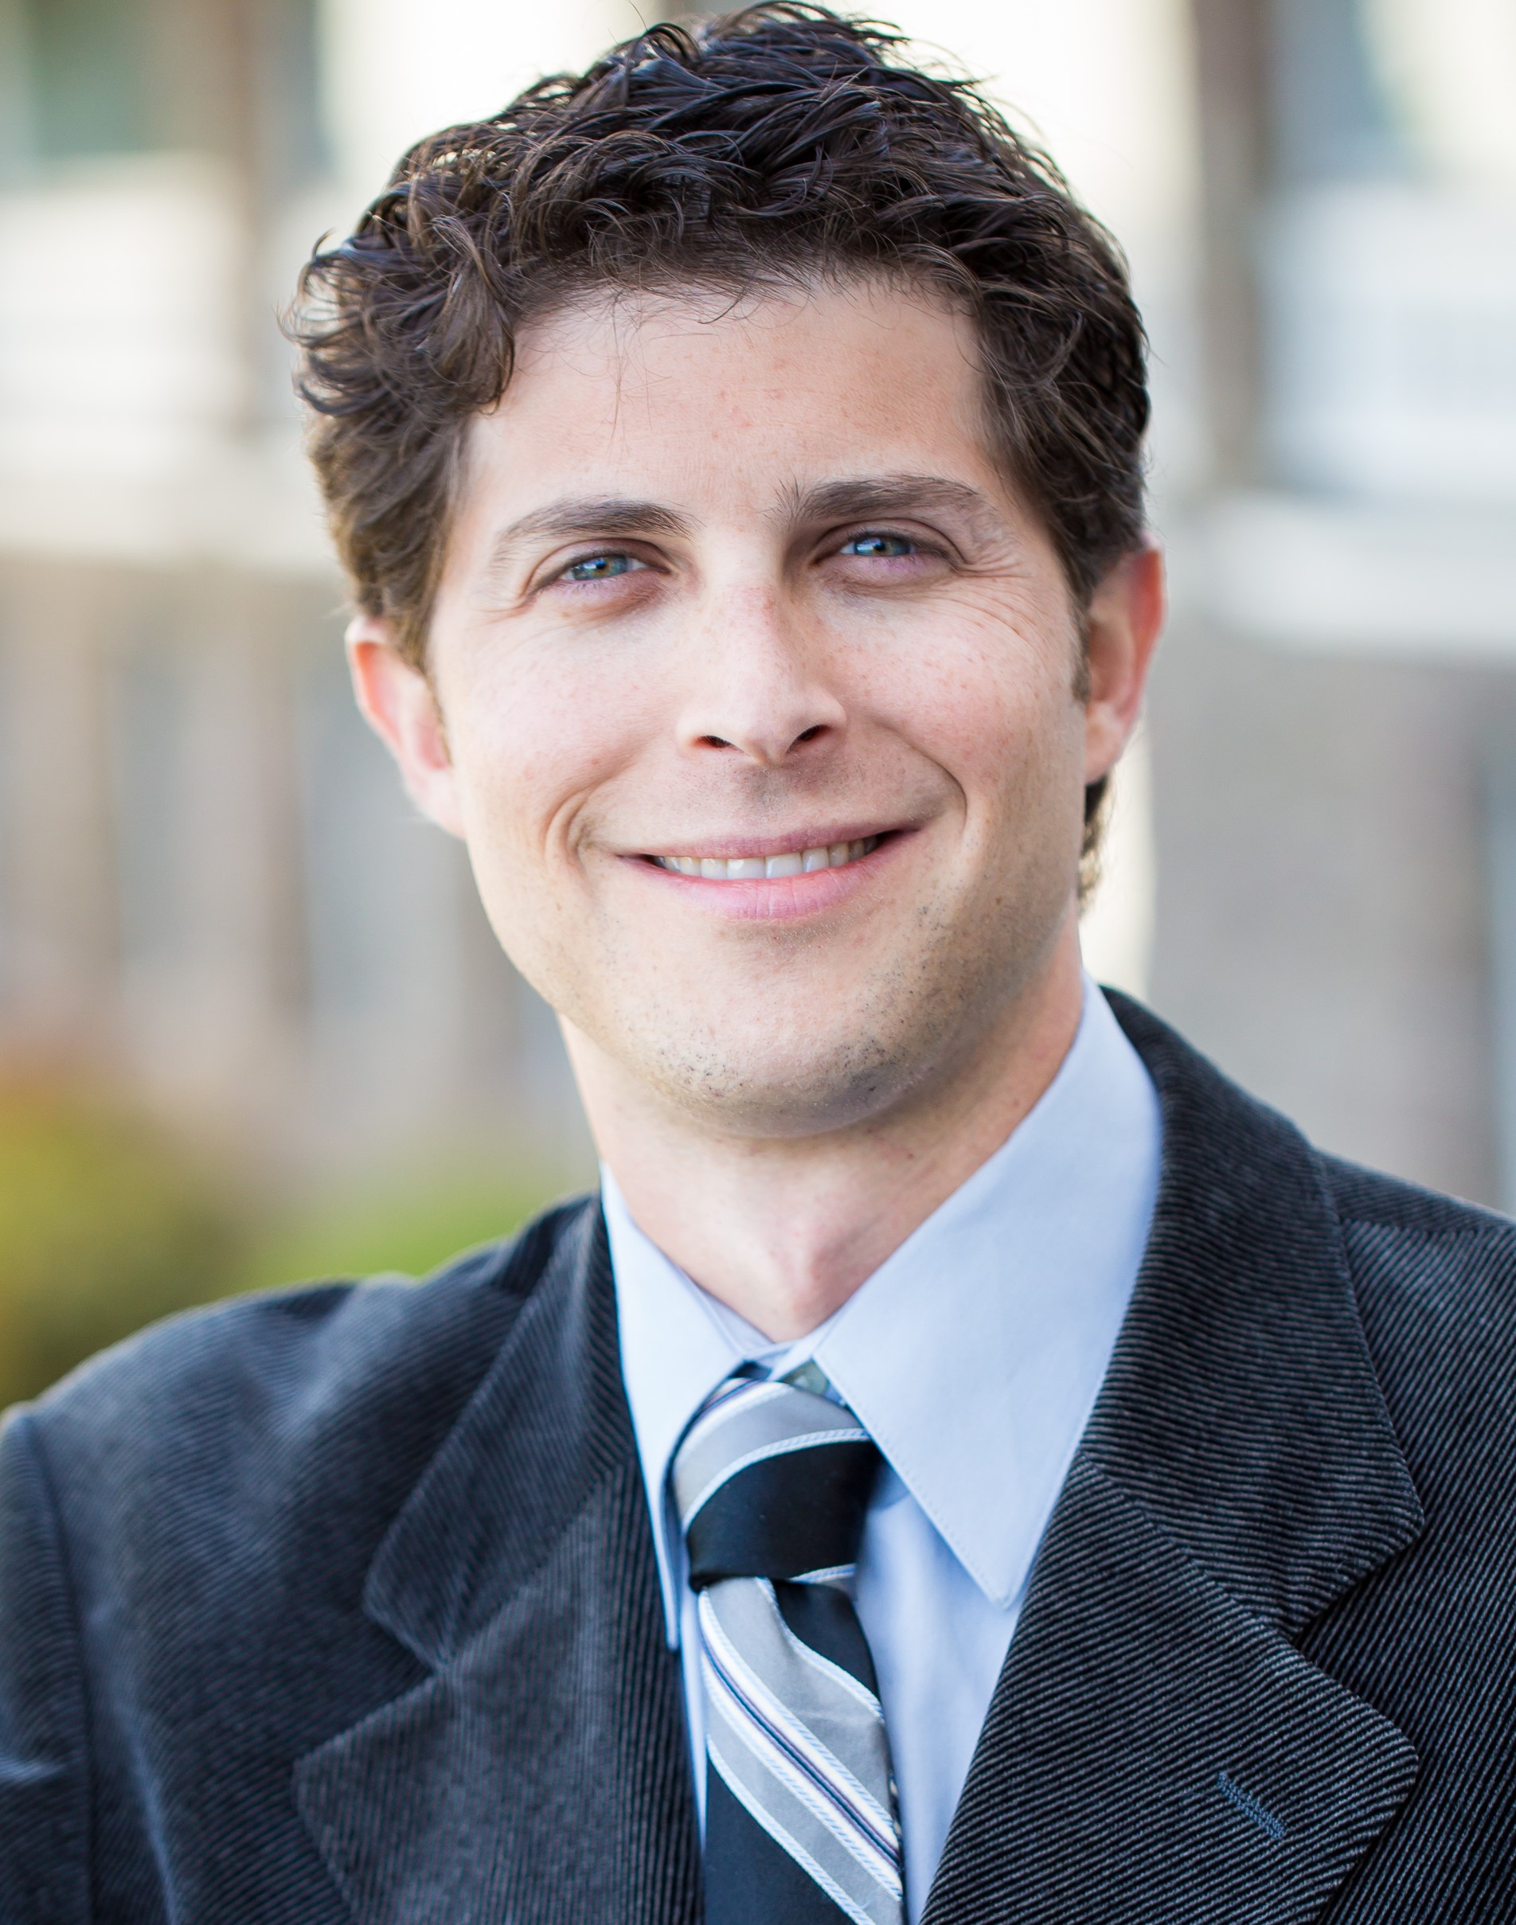
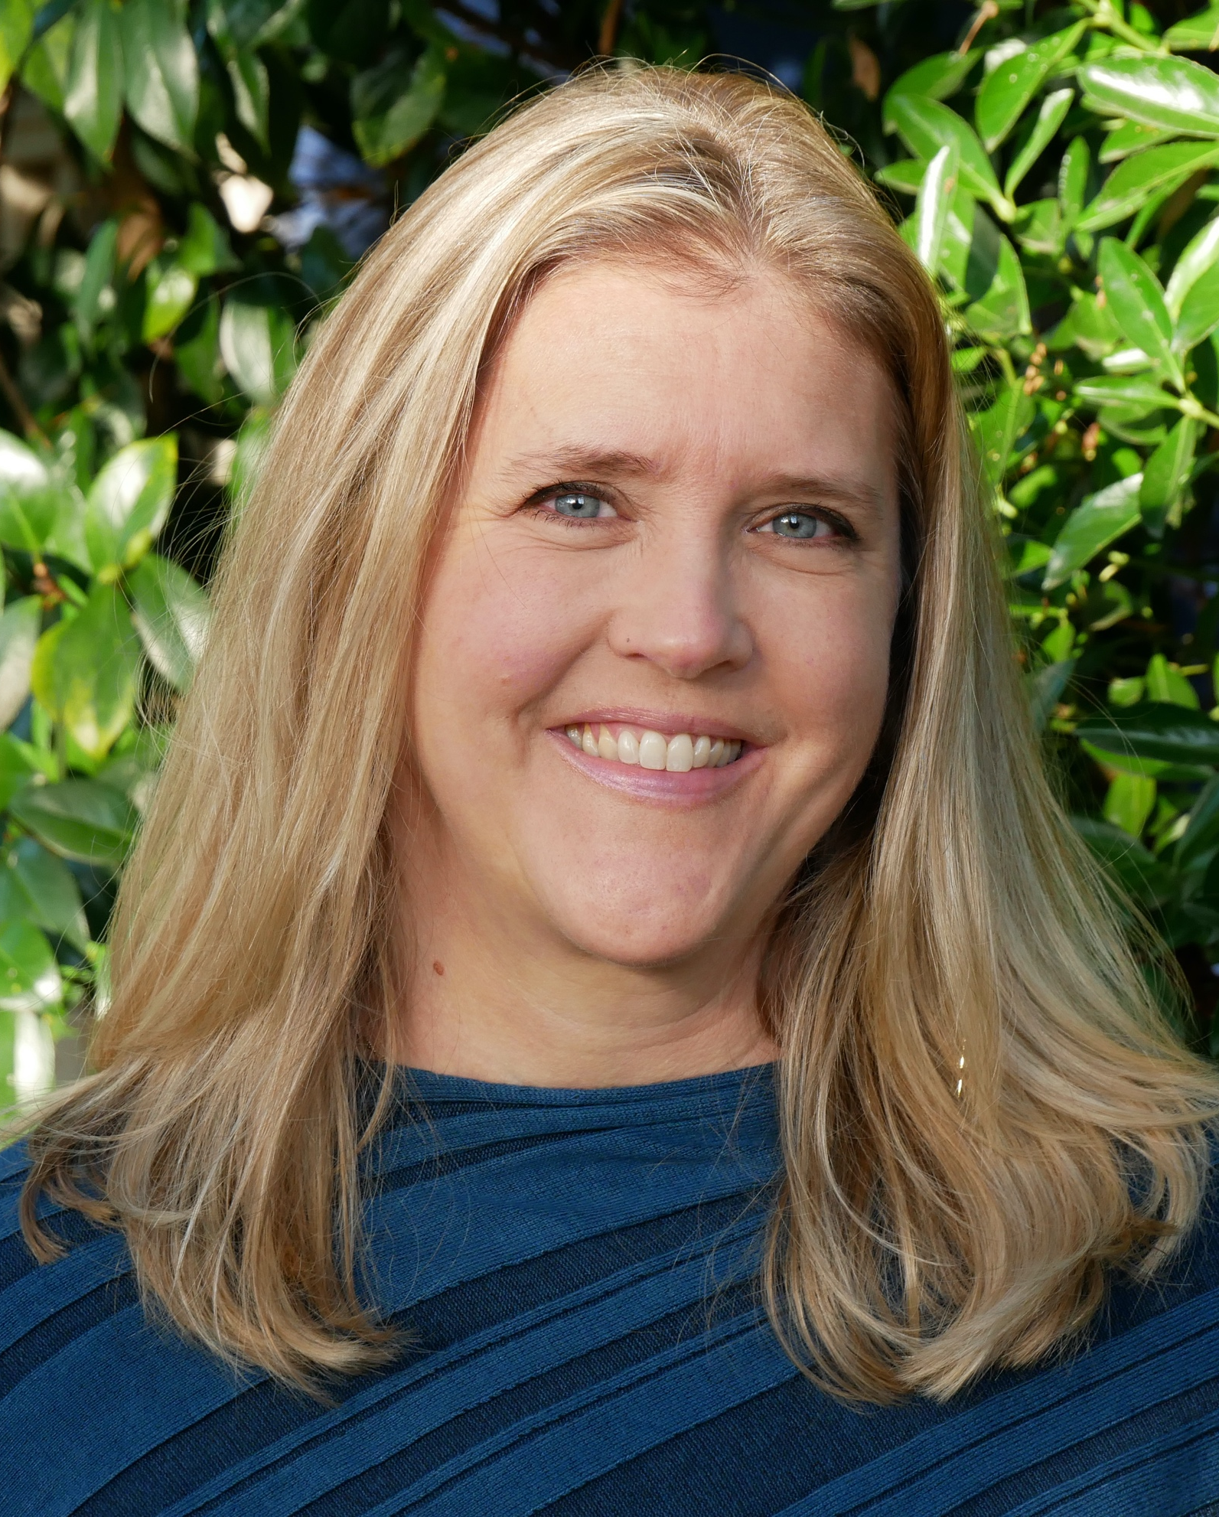

Ryan Humphries, BS, CSCS
Lylen Ferris, ND

Todd Born, ND, CNS

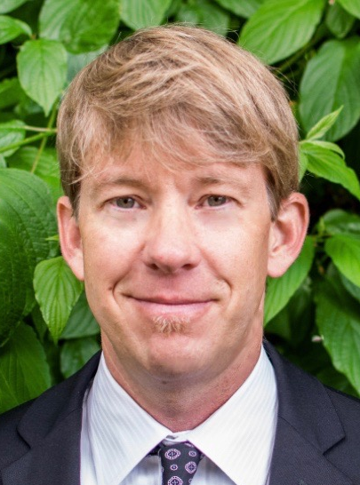
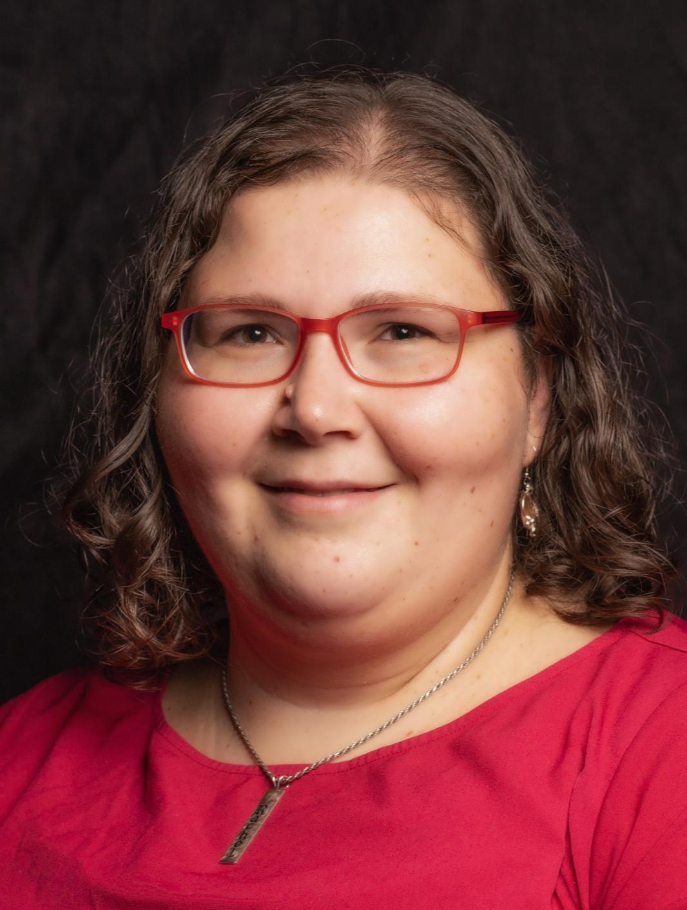
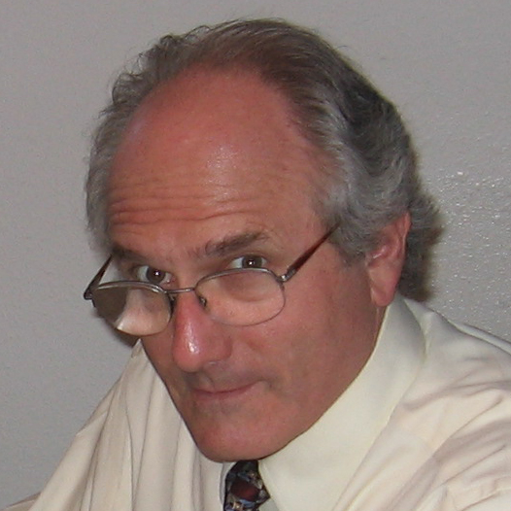

Ryan Bradley, ND, MPH
Jared Zeff, ND, VNMI

Rachel M. Klein, ND, DC, DACNB, FIBFN-CNDH
Taylor Bean, ND

Autoimmune Disease: A Route to Resolution
presented by Todd A. Born, ND, CNS
The Impact of the Deep Roots of Childhood Trauma on Adult Health
presented by Lylen Ferris, ND

Strong Medicine
presented by Ryan Humphries, BS, CSCS

Infant Immunity and Vaccine Optimization
Pre-recorded video presented by Taylor Bean, ND

Find the Root - Seeking the Causes of Illness
presented by Jared Zeff, ND, VNMI

Sex on the Brain
presented by Rachel M. Klein, ND, DC, DACNB, FIBFN-CNDH

Address the Root Cause: Overcoming Barriers to Behavior Change
presented by Ryan Bradley, ND, MPH

Click Here for the complete schedule of events.

Conference Registration Fees

- MEMBER OF NEIGHBORING ND ASSOCIATION: $250.00
- NON-MEMBER: $300.00

Hotel Reservations

The conference will be held at the Embassy Suites by Hilton Denver Tech Center North, 7525 East Hampden Avenue, Denver, CO 80231. Phone: (303) 696-6644 The Embassy Suites offers a great group rate of $109 plus tax per night for suites with one king bed or two queen beds. Click here to reserve your room.

Conference Exhibitors

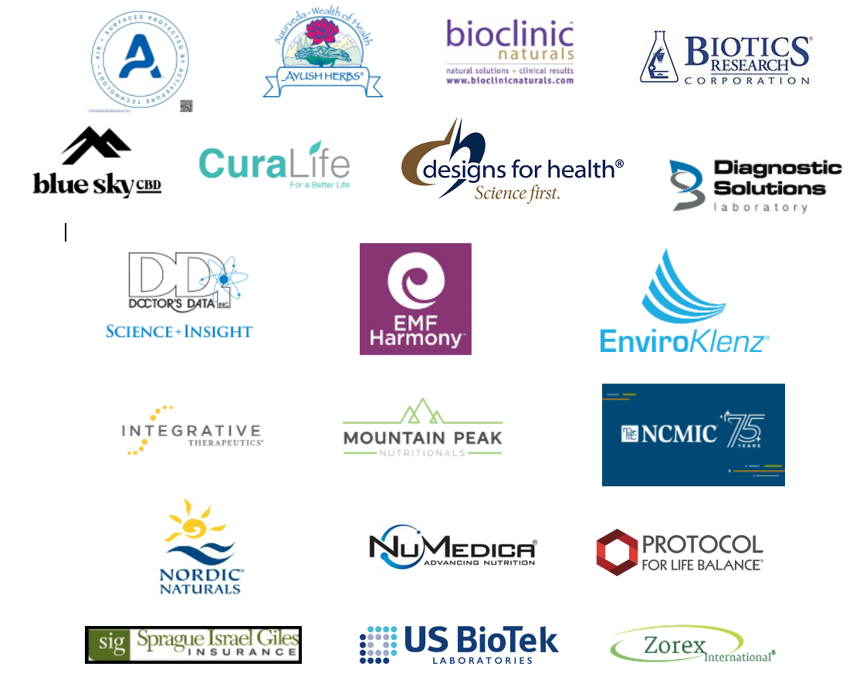
CoAND Conference Refund/Cancellation Policy

Replacement of a registered CoAND attendee by a business colleague/co-worker will be accepted. A $25 USD processing fee will apply to all substitutions. Substitutions must be submitted in writing via email to director@aznma.org. The new registrant will be responsible for the $25 refund free and will have to pay the difference in registration fees based on their membership type.

Cancellation of registration must be submitted in writing via email to director@aznma.org on or before October 1, 2021 to receive a 50% refund. No refunds will be issued after October 1, 2021. Note: no refunds will be granted to no-shows but recorded content may be available.

Questions? Please contact Baron Glassgow, Conference Manager, at director@aznma.org or by phone at 480-921-3088.

